Issue 1: # Affected Processing Activities’ metric is not working as expected.

When the In scope is ‘True’ and Compliance Status is ‘Not Ok’ and ‘UNSPECIFIED’ , Please cross check the GDPR.

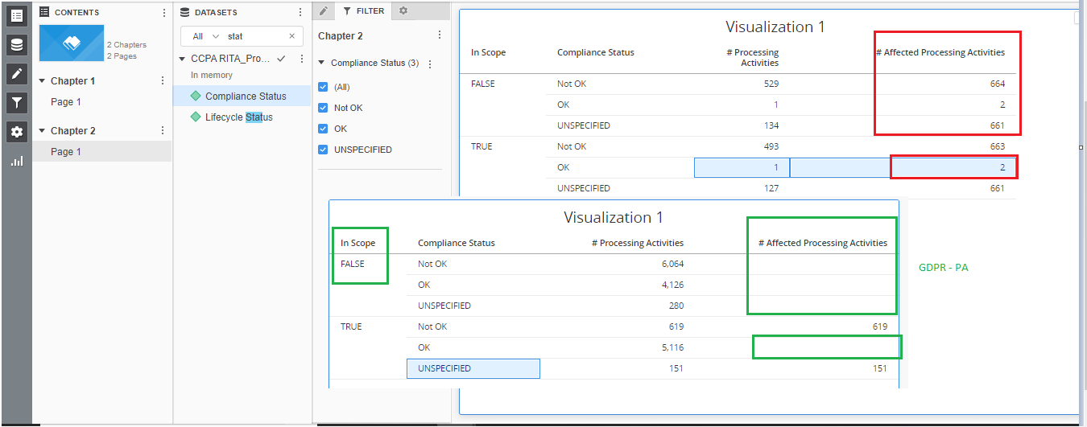

Issue 2: ‘# Pending Compliance Controls’.

The metric is not working as per the definition.

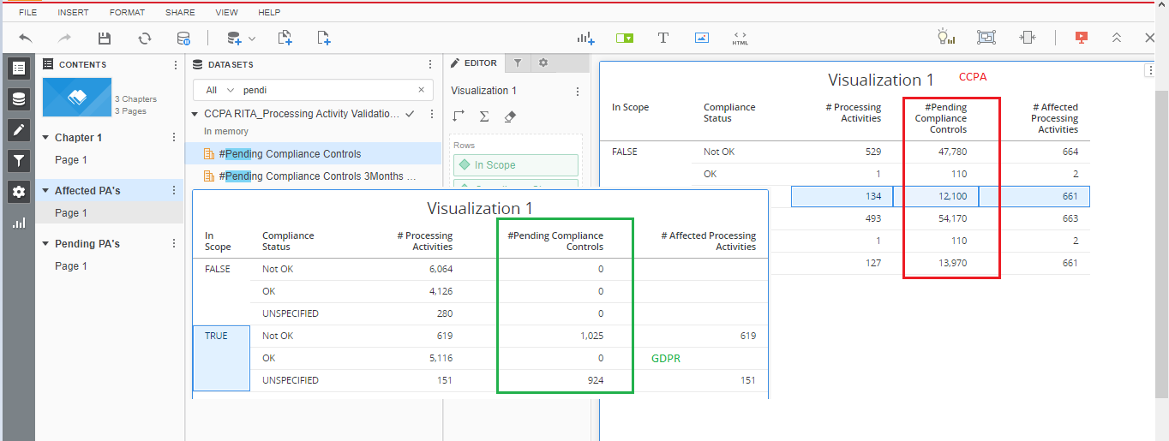

Issue 3 : ‘# Completed Compliance’ metric and Total Compliance metrics are not working fine.

Definition : Inscope =’True’ and status=’Ok’ ,

Not sure of the calculation of the ‘Ok’ metrics.

And it is calculated for the False as well.

Total Compliance Metrics should be equivalent for the ‘# Pending Compliance Controls’

